CELL PHONES RUINING RELATIONSHIPS

A study from Brigham Young University found that of the 143 participating women, the majority reported that phones, computers and other devices were significantly disrupting their relationships. In fact, the study found, excessive phone use by loved ones lowers overall well-being and can even cause depression.
When your partner is occupied with Instagram, Facebook or texting, it can feel a lot like being shunned. When the one you love is on the phone instead of focusing their attention on you, it’s easy to feel rejected. The message you may be getting is, “I am more interested in these random people than in you”; “My phone is more important than you”; or worse still, “You are not worth my attention.”
MRI studies show that your brain responds to rejection in the same way as it does to physical pain. In fact, rejection piggybacks on physical pain pathways. This is why rejection hurts so much. The brain responds so similarly that Tylenol actually reduces emotional pain as well as physical suffering.
If you think technoference might be causing problems in your relationship consider addressing it in these ways:
1. Acknowledge usage that is valid and acceptable first.
2. Agree on fair expectations to create a balance.
3. Create technology-free zones. Agree on places, situations and times when devises are prohibited (the bedroom, when you’re out to dinner, after 9 pm).
Continue to communicate with your partner about what you feel is bothersome about his or her devise usage. Also be sure to acknowledge the successes of how the new guidelines or limitations make you feel more valued, connected and loved.
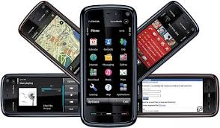
By: Gina Gudddat – Author of “Love Metabolism- Turning Up the Heat in Your Relationship) Available on Amazon.com (Psychology Today April 2015 – Original article by Guy Winch, PH.D. author of Emotional First Aid)

